----------------

NamaPeserta : Pieter Christian Wenji

Kode Peserta : FSDO002ONL015

Tugas : Assigment 2

----------------

**A. Buat Database baru dengan nama staff**

CREATE DATABASE STAFF;

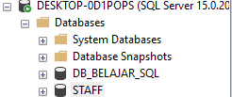

--------------------------------------------------------------------------------------------------------------------------------------

**B. Buat Table data_staff**

CREATE TABLE DATA_STAFF

(

NIK INT PRIMARY KEY,

NAMA VARCHAR(50) NULL,

ALAMAT VARCHAR(200) NULL,

HANDPHONE VARCHAR(15) NULL

);

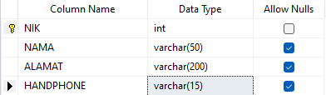

--------------------------------------------------------------------------------------------------------------------------------------

**C. Masukkan data ke dalam table data_staff**

INSERT INTO DATA_STAFF (NIK, NAMA, ALAMAT, HANDPHONE)

VALUES (1001, 'ASEP', 'BANDUNG', '081234123914');



--------------------------------------------------------------------------------------------------------------------------------------

**D. Masukkan lebih dari 1 data ke dalam table data masih dalam table diatas**

INSERT INTO DATA_STAFF (NIK, NAMA, ALAMAT, HANDPHONE)

VALUES (1002, 'DANI', 'JAKARTA', '082980112930'),

(1003, 'BUDI', 'SURABAYA', '082431764901');

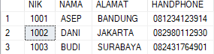

--------------------------------------------------------------------------------------------------------------------------------------

**E. Tambahkan kolom baru pada table data_staff yaitu joindate sekaligus masukan 1 data kedalam table data_staff**

ALTER TABLE DATA_STAFF

ADD JOINDATE DATE;

INSERT INTO DATA_STAFF (NIK, NAMA, ALAMAT, HANDPHONE,JOINDATE)

VALUES (1004, 'ILHAM', 'BANDUNG', '081234123914','2021-11-22');

UPDATE DATA_STAFF

SET JOINDATE = '2021-11-22'

WHERE NIK = 1001;

UPDATE DATA_STAFF

SET JOINDATE = '2021-10-17'

WHERE NIK = 1002;

UPDATE DATA_STAFF

SET JOINDATE = '2021-10-18'

WHERE NIK = 1003;

UPDATE DATA_STAFF

SET JOINDATE = '2021-10-19'

WHERE NIK = 1004;

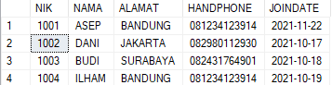

--------------------------------------------------------------------------------------------------------------------------------------

**F. Tampilkan 2 data SQL kalian sekarang**

SELECT TOP 2 *

FROM DATA_STAFF;

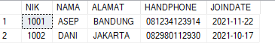

--------------------------------------------------------------------------------------------------------------------------------------

**G. Tampilkan 3 data SQL kalian sekarang**

SELECT TOP 3 *

FROM DATA_STAFF;

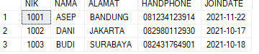

--------------------------------------------------------------------------------------------------------------------------------------

**H. Buat Table baru staffoutsource dengan isi yang sama seperti data_staff**

CREATE TABLE STAFFOUTSOURCE

(

NIK INT PRIMARY KEY,

NAMA VARCHAR(50) NULL,

ALAMAT VARCHAR(200) NULL,

HANDPHONE VARCHAR(15) NULL,

JOINDATE DATE NULL

);

INSERT INTO STAFFOUTSOURCE (NIK, NAMA, ALAMAT, HANDPHONE, JOINDATE)

SELECT NIK, NAMA, ALAMAT, HANDPHONE, JOINDATE

FROM DATA_STAFF;

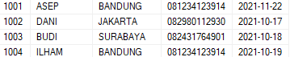

--------------------------------------------------------------------------------------------------------------------------------------

**I. Masukkan 10 data baru ke table staffoutsource**

INSERT INTO STAFFOUTSOURCE (NIK, NAMA, ALAMAT, HANDPHONE, JOINDATE)

VALUES (1005, 'STEVE', 'BANDUNG', '0212313131', '2021-01-24'),

(1006, 'MAIKEL', 'JAKARATA', '082431134901', '2020-06-13'),

(1007, 'BUDI', 'SURABAYA', '082431764901', '2021-11-24'),

(1008, 'STEPHANIE', 'MEDAN', '293109831', '2019-12-12'),

(1009, 'ILHAM', 'BANDUNG', '90193910', '2021-10-17'),

(1010, 'BEDEDE', 'BOGOR', '08231831', '2020-08-18'),

(1011, 'ILHAM 2', 'BANDUNG', '90193910', '2021-10-01'),

(1012, 'NINI', 'KALIMANTAN', '0823810123', '2020-11-11'),

(1013, 'NANA', 'KALIMANTAN', '0823810124', '2021-11-11'),

(0014, 'LISA', 'SULEWESI', '802198301', '2021-01-05');

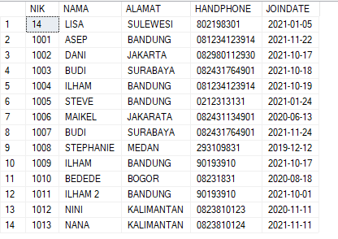

--------------------------------------------------------------------------------------------------------------------------------------

**J. Tampilkan data pada 2 Table yang sudah kalian buat dengan joindate yang sama**

SELECT *

FROM DATA_STAFF

INNER JOIN STAFFOUTSOURCE

ON DATA_STAFF.JOINDATE = STAFFOUTSOURCE.JOINDATE;

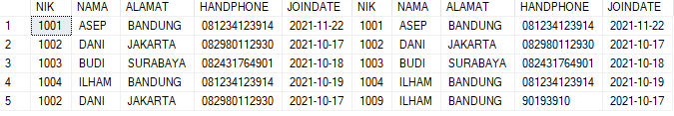

--------------------------------------------------------------------------------------------------------------------------------------

**K. Tampilkan seluruh data sebelah kanan yang sama pada table staff_outsource**

SELECT *

FROM STAFFOUTSOURCE

RIGHT JOIN DATA_STAFF

ON STAFFOUTSOURCE.NIK = DATA_STAFF.NIK;



--------------------------------------------------------------------------------------------------------------------------------------

**L. Tampilkan seluruh data staff sebelah kiri yang punya nilai tidak sama akan bernilai null**

SELECT *

FROM STAFFOUTSOURCE

LEFT JOIN DATA_STAFF

ON STAFFOUTSOURCE.NIK = DATA_STAFF.NIK;

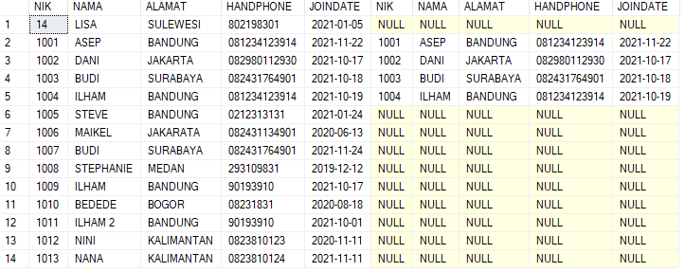

--------------------------------------------------------------------------------------------------------------------------------------

**M. Tampilkan seluruh data antara 2 tabel baik itu tidak punya kesamaan dan bernilai null.**

SELECT * FROM DATA_STAFF

UNION

SELECT * FROM STAFFOUTSOURCE;



